Online Proctor System
Internship/Project (3180701)

A Project Report Submitted by

Parth Ahuja – 200570107024
Savan Pethani - 200570107006

in partial fulfilment for the award of the degree of

Bachelor of Engineering
in
Computer Engineering

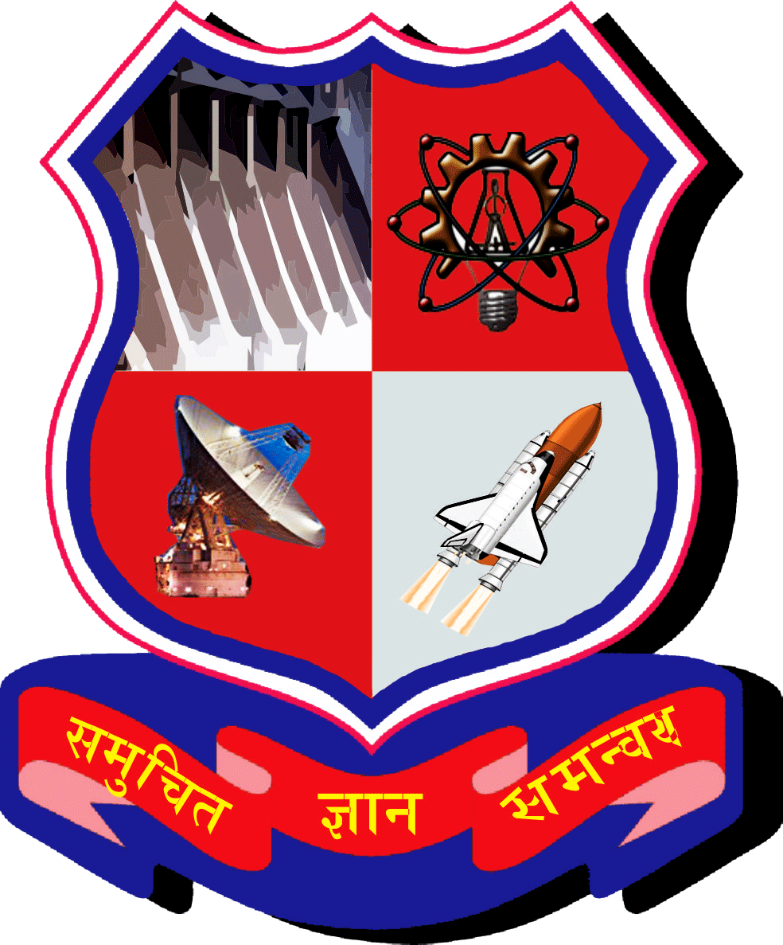

Faculty of Engineering (057)
Marwadi Education Foundation, Rajkot

Gujarat Technological University, Ahmedabad
2023-24

Marwadi Education Foundation
Faculty of Engineering (057)
Computer Engineering Department
2023-24

CERTIFICATE

This is to certify that the project entitled Online Proctor System has been carried out by Parth Ahuja – 200570107024, Savan Pethani - 200570107006 under my guidance in partial fulfilment of the degree of Bachelor of Engineering in Computer Engineering of Gujarat Technological University, Ahmedabad during the academic year 2023-24.

Date: ____________________

Internal Guide Head of the Department

Prof. Samir Kariya Dr. Kunal Vaghela
Assistant Professor

Undertaking about Originality of Work
We hereby certify that we are the sole authors of this Internship/Project report and that neither any part of this Internship/Project project report nor the whole of the Internship/Project Project report has been submitted for a degree by other student(s) to any other University or Institution.
We certify that, to the best of our knowledge, the current Internship/Project report does not infringe upon anyone’s copyright nor violate any proprietary rights and that any ideas, techniques, quotations or any other material from the work of other people included in our Internship/Project report, published or otherwise, are fully acknowledged in accordance with the standard referencing practices. Furthermore, to the extent that we have included copyrighted material that surpasses the boundary of fair dealing within the meaning of the Indian Copyright (Amendment) Act 2012, we certify that we have obtained a written permission from the copyright owner(s) to include such material(s) in the current Project report and have included copies of such copyright clearances to our appendix.
We have checked the write up of the present Internship/Project report using anti-plagiarism database and it is in the allowable limit. In case of any complaints pertaining to plagiarism, we certify that we shall be solely responsible for the same and we understand that as per norms, University can even revoke BE degree conferred upon the student(s) submitting this Internship/Project report, in case it is found to be plagiarised.
Team:

Enrolment Number | Name | Signature
200570107024 | Parth Ahuja
200570107006 | Savan Pethani

Place: _____________ Date: _____________
Acknowledgments
We have taken many efforts in this project. However, it would not have been possible without the kind support and help of many individuals and organizations. We would like to extend our sincere thanks to all of them.

We are highly indebted to Prof. Samir Kariya for their guidance and constant supervision as well as for providing necessary information regarding the Design Engineering Project Titled “Online Proctor System”. We would like to express our gratitude towards our Head of the Department Dr. Krunal Vaghela and other staff members of Computer Engineering Department, Marwadi University for their kind co- operation and encouragement which helped us in completion of this project.

We even thank and appreciate our colleague in developing the project and people who have willingly helped us out with their abilities.

